Story 04 Add a Book - v2

Changes with respect to v2: see text in red

## Description

As a user

I want to add a book

So that it will be stored in the database

## Wireframe

Happy case:

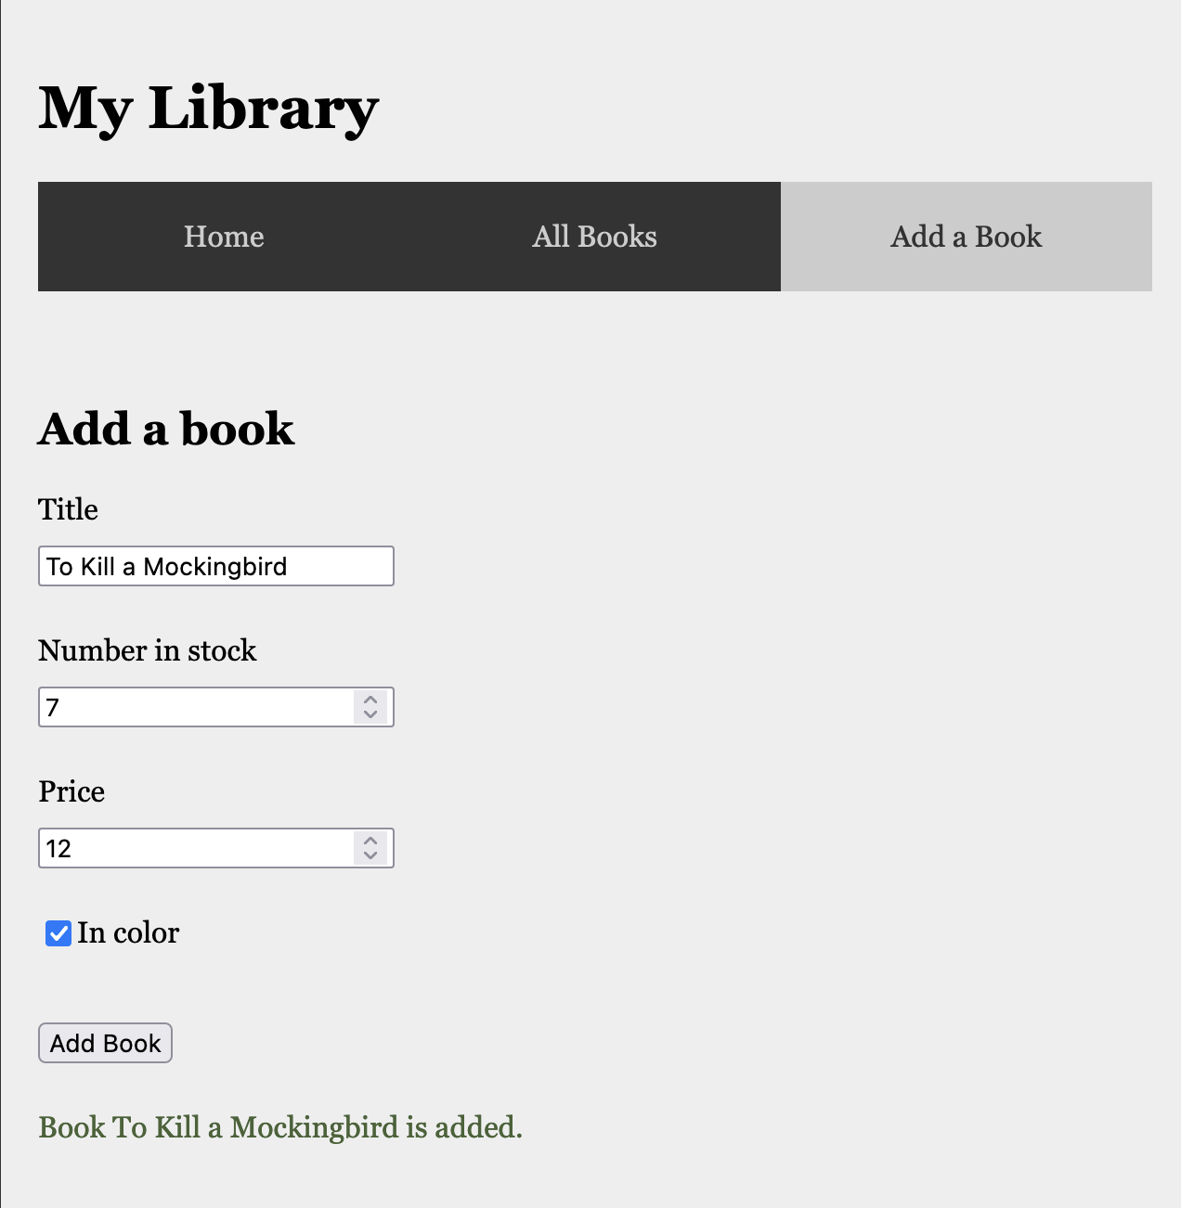

Unhappy case – Title is not unique:

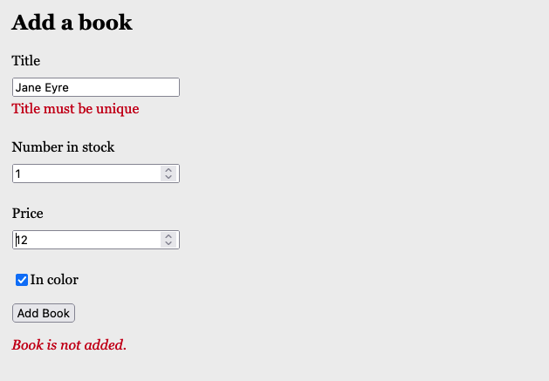

Unhappy case – Field errors

## Acceptance Criteria

* A book with given title can only be added once
* Book title is required and has length >3; the value of “number in Stock” is between 1 and 5 (including); the price must be positive; the default value for “inColor” is false.
* When a user fills in all fields and there is no book in the collection with the given title
  + A confirmation text with book title is shown below the form
  + the book is added to the database
  + the book is rendered on the overview page
* When a user tries to add a book with title that already is taken in the collection
  + the text “Book title must be unique” is displayed under the input field for “title”
  + the book is not added to the database
* If the user wants to add a book with invalid fields,
  + an appropriate error message is displayed under the corresponding input field.
  + The book is not added to the database

## Technical Requirements

* The book is sent to the back-end through the URL <http://localhost:8080/api/book/add>
  + POST request
  + Body: JSON object with fields “title” (String), “numberInStock” (int),

“price” (double), “inColor” (Boolean)

* + Response – Happy case: JSON book object with fields “id” (int), “title” (String), “numberInStock” (int), “price” (double), “inColor” (Boolean), “priceInDollar” (double)
  + Response – Unhappy case: “400 BAD REQUEST” with a JSON error message with fields corresponding to the field that generates the error and appropriate error message.

"price": "Price must be positive"

"title": "Title is required"

"title": "Title must have at least 3 chars"

"title": "Title must be unique"

"numberInStock": "Number in stock must be between 1 and 5"

* The book is stored in a h2 database.